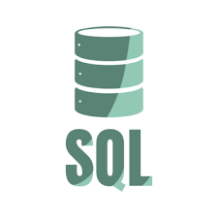
blinkit Analysis
BUSINESS REQUIREMENT
To conduct a comprehensive analysis of Blinkit's sales performance, customer satisfaction, and inventory distribution to identify key insights and opportunities for optimization using various KPIs and visualizations in Power BI.
KPI's Requirements
- Total Sales: The overall revenue generated from all items sold.
- Average Sales: The average revenue per sale.
- Number of Items: The total count of different items sold.
- Average Rating: The average customer rating for items sold.

BUSINESS REQUIREMENT
Granular Requirements
1. Total Sales by Fat Content:
- Objective: Analyse the impact of fat content on total sales.
- Additional KPI Metrics: Assess how other KPIs (Average Sales, Number of Items, Average Rating) vary with fat content.
2. Total Sales by Item Type:
- Objective: Identify the performance of different item types in terms of total sales.
- Additional KPI Metrics: Assess how other KPIs (Average Sales, Number of Items, Average Rating) vary with fat content.
3. Fat Content by Outlet for Total Sales:
- Objective: Compare total sales across different outlets segmented by fat content.
- Additional KPI Metrics: Assess how other KPIs (Average Sales, Number of Items, Average Rating) vary with fat content.
4. Total Sales by Outlet Establishment:
- Objective: Evaluate how the age or type of outlet establishment influences total sales.

BUSINESS REQUIREMENT
Chart's Requirements
5. Percentage of Sales by Outlet Size:
- Objective: Analyse the correlation between outlet size and total sales.
6. Sales by Outlet Location:
- Objective: Assess the geographic distribution of sales across different locations.
7. All Metrics by Outlet Type:
- Objective: Provide a comprehensive view of all key metrics (Total Sales, Average Sales, Number of Items, Average Rating) broken down by different outlet types.

